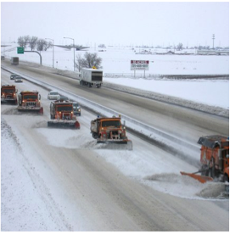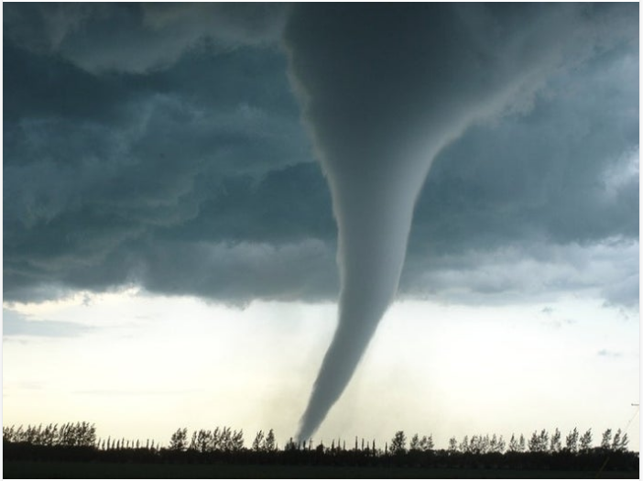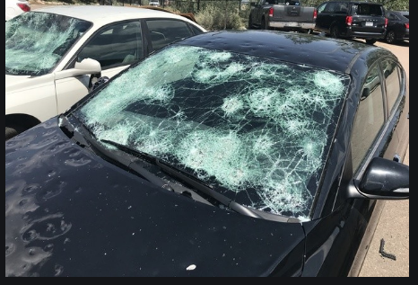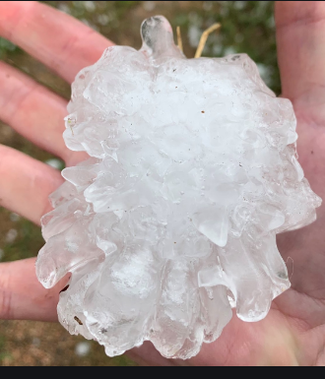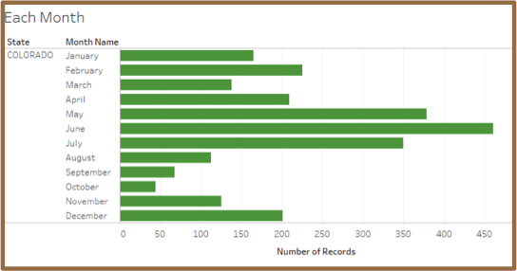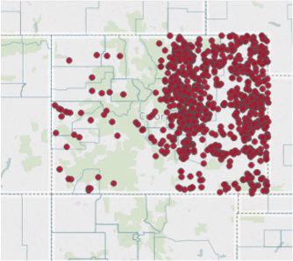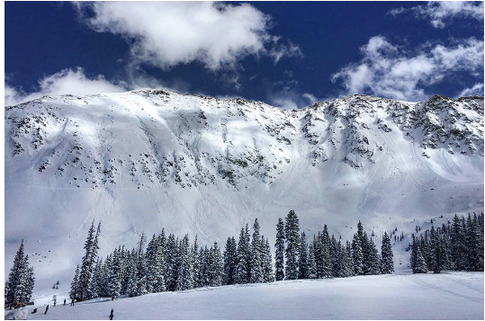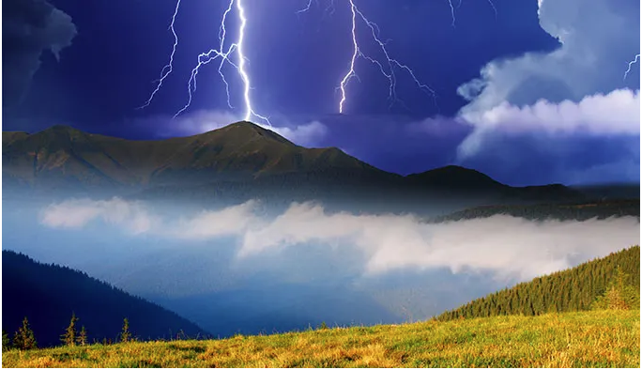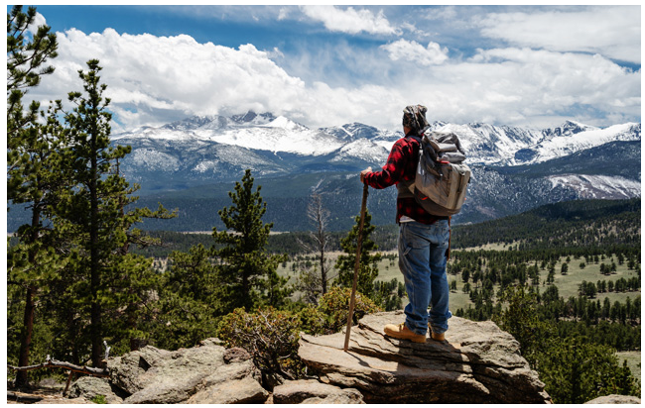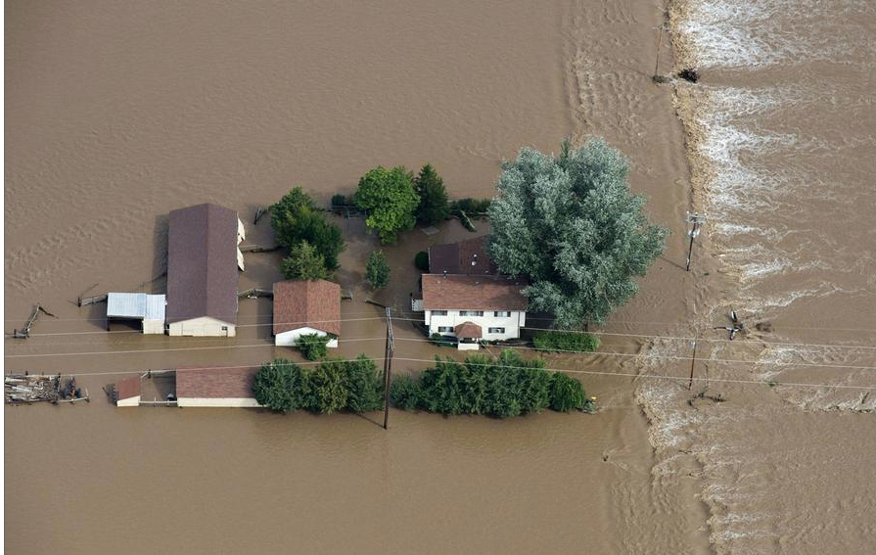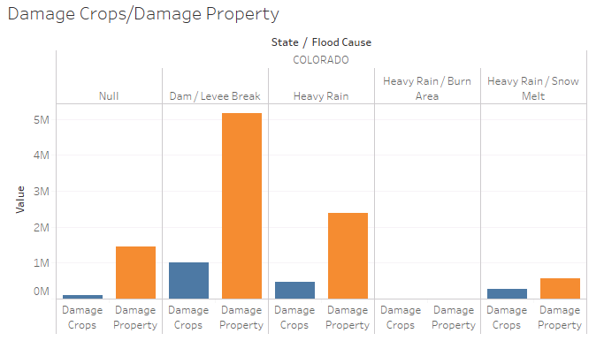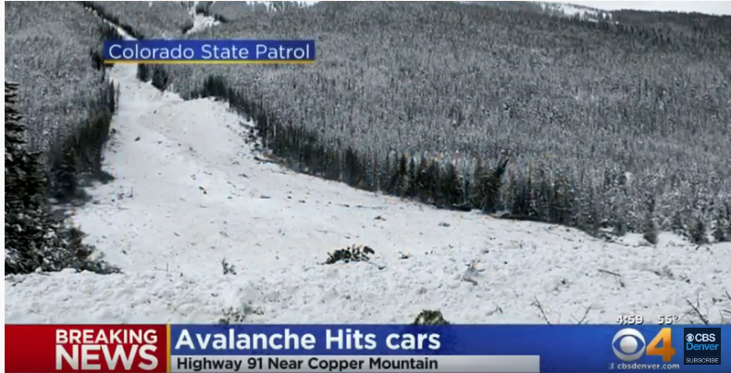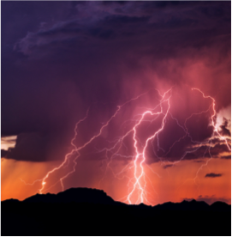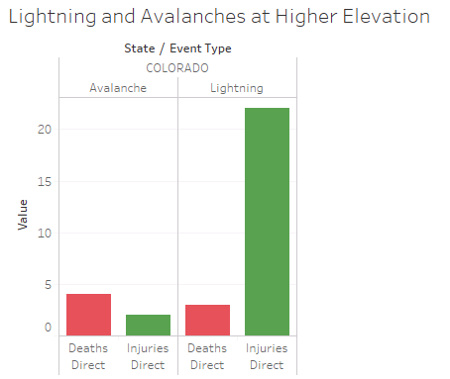

* **Winter Storm**
* **Winter Weather**
* **Heavy Snow**
* **High Winds**

**December-March**

**Storm Tips**

* **Shelter-in-place**
* **Avoid higher elevations in the afternoon**
* **Stay informed with our weather app**

**Storm Tips**

**For road updates and Mountain Travel resources:** <https://www.codot.gov/travel/winter-driving>

**Where and When do Storms Occur?**

* **Most Storms occur east of the Continental Divide**
* **May-July is the most active weather in Colorado**
* **December-March is the second most active weather period**

**May – July**

* **Hail**
* **Thunderstorm Wind**
* **Tornados**
* **Flash Floods**

Questions?

Call: 1-720-WEA-DATA

Email: coloradoweatherdata@colorado.gov

Colorado Data Science

Colorado Outdoors Weather Public Safety Tips

## Weather Events

Based on the 2015-2016 NOAA Public Storm Data

Lightning

* Lightning is the primary source of injury from weather events with over 20 people struck a year. Colorado’s high altitude makes it more susceptible.
* **On average, it kills around 3.5 people and injures around 17 per year. This is consistent with our data findings** (McKee, 2019) **of 22 injuries and 3 deaths.**
* Most strikes occur between 1pm and 3pm in the spring/summer months and usually hit people who are hiking or enjoying the outdoors.

**Lightning Safety:**

* Stay below tree line (10,000 ft.) in afternoons
* If stuck in an open area: crouch and do not lie on ground, keep arms/legs in to body and minimize contact with ground.
* Stay away from water, metal and wet items,
* Wait 30 minutes until thunder ends to leave shelter (source: Weather.gov/NOAA (2019)

Avalanches

* Avalanches affect highways, local roads, airports, towns and cities, not just ski areas.
* On March 8, 2019 roughly 346 Avalanches had been reported over 7 days (Berwyn, 2019). There may not be as many deaths but the risk increases every year with global warming.
* **The past 10 winters there have been on average 27 deaths in the U.S.**
* **There were 4 deaths and 2 injuries in our 2015-2016 data.**

**Avalanche Safety**

* Get training. Carry transceiver, shovel, and probe.
* Know the slope, snowpack, and trigger.
* Colorado Avalanche Information Center (CAIC) has up to date data.
* Beware when driving on high elevation roads. (Source: Weather.gov/NOAA, CAIC (2019)

### Lightning and Avalanches at Higher Elevation

Flooding is the most common cause of damaged crops and property. The graph to the right shows us that damaged property is mostly caused by Dam/Levee breaks, Heavy Rain, and other causes (null). Damaged Crops have the same causes. Flooding is responsible for over 8 million reported damaged property and 2 million reported damaged crops. (Source: NOAA 2015-2016 data).

Flood Safety: Turn Around Don’t Drown at Flooded Roads, Know what to do before, during and After a Flood.

Before a Flood: create communications plan, assemble emergency kit, know your risk, sign up for notifications, prepare your home/family/pets, charge essential electronics, leave.

During: stay informed, get to higher ground, obey evacuation orders, practice electrical safety, avoid flood waters

After: stay informed, avoid flood waters/disaster areas, heed road closed and cautionary signs, wait for all clear, contact family and loved ones.

Source: National Weather Service /NOAA (2019)

S

# Flood Damage: Crops and Property

**Lightning injured 22 and killed 3, while Avalanches killed 4 and injured 2. (Source: NOAA 2015-2016 data)**

References

* Berwyn, B. (2019) Avalanches Menace Colorado as Climate Change Raises the Risk. Retrieved from: <https://insideclimatenews.org/news/08032019/avalanche-climate-change-risk-snow-storm-forecast-colorado-switzerland>
* Colorado Avalanche Information Center –CAIC (2019) Statistics and Reporting. Retrieved from: <https://avalanche.state.co.us/accidents/statistics-and-reporting/>
* CODOT.GOV (2019) Winter Driving. Retrieved from: <https://www.codot.gov/travel/winter-driving>
* McKee, S. (2019) The Numbers Behind Lightning Strikes and Casualties in Colorado. Retrieved from: <https://www.outtherecolorado.com/the-numbers-behind-lightning-strikes-and-casualties-in-colorado/>
* NOAA 2015-2016 Storm Events. Retrieved from: https://ncdc.noaa.gov/stormevents/
* Weather.gov/NOAA (2019) Avalanche Safety tips. Retrieved from: <https://www.weather.gov/safety/winter-avalanche>
* Weather.gov/NOAA (2019) Lightning Safety Tips and Resources. Retrieved from: <https://www.weather.gov/safety/lightning>
* Weather.gov/NOAA (2019) Flood Safety Tips and Resources. Retrieved from: <https://www.weather.gov/safety/flood>